# **Character Recognition using Machine Learning.**

Welcome to the CharRecogProject project! This document is to guides users on how to use this test program, benchmark different machine Learning models and find out their performance.

# **Get code and data**

Code is available in GitHub repository. Use the below link to Get the latest version.

Note: Set up the python 3 environment with the required packages before running the code. Details of required python libraries to run this project are listed in requirement.txt file.

<https://github.com/piyushbhadauriya/CharRecogProject>

To run the test program use /CharRecog/main.py file in the repo



PS: Notebooks and the documents in the github root folder are some unorganized code snippets. CharRecog folder has the runnable code for the Test program

# **Using the Test Program**

Aim of this Test program is to benchmark the different Machine learning models and test them against different test datasets or image files. Model are pre-trained and will be loaded from a file, but program also has capability to train new models.

Test program’s main Menu has five function/selections. To select a function, input the index of function (ex: Input 1 to select Load Data Function). Loading Data and Model is required before running other function. Following section will briefly explain these functions.

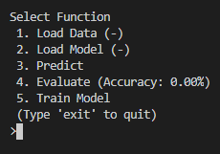

## Load data: -

This function is to load the dataset from csv files stored in the /data folder. This project is using EMNIST dataset ([link](https://www.kaggle.com/crawford/emnist)) to train the model. All the datasets have three component train data, test data and mapping table. Here is the list of six available datasets and their brief description. -> **1) BY MERGE, 2) BYCLASS, 3) BALANCED, 4) DIGITS, 5) LETTERS, 6) MNIST**

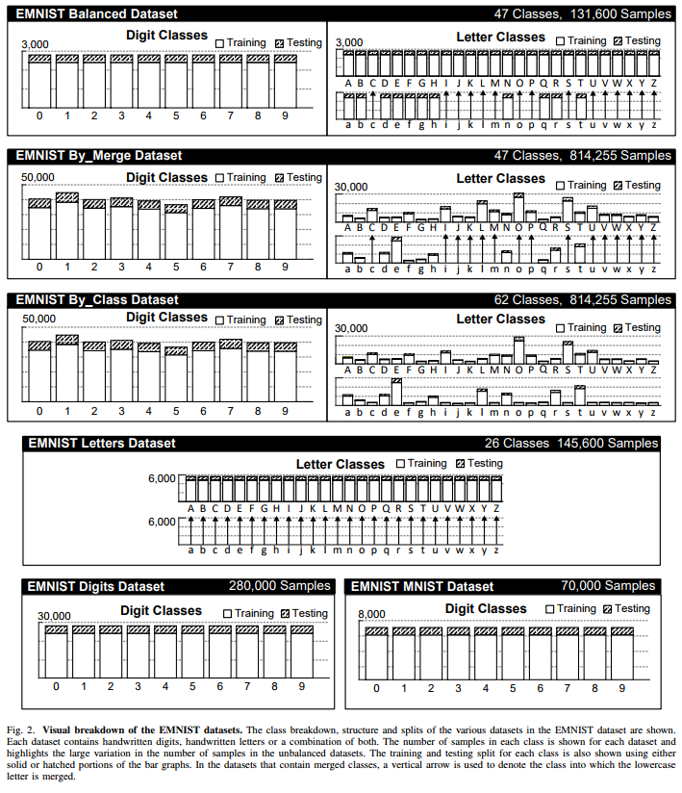

## Load Model: -

This function shows the list pretrained Machine learning models available to test in /model folder. Select and load a model by entering its index. After training new models they will also be available to load from this menu. CNN model function is loaded from Json file and corresponding weights are stored in a h5 file.

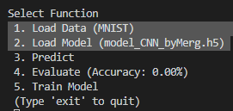

Note : We can see the current dataset/model names in main menu after loading them.

## Predict: -

**From Test Set -**

A model can predict output(character) from a stored Image file or from a datapoint in current test data. Prediction a character from a test set will display predicted output by the model and actual value stored (labeled) in the data set

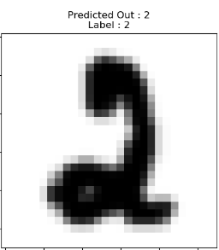

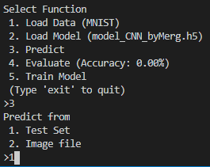

**From Image File -**

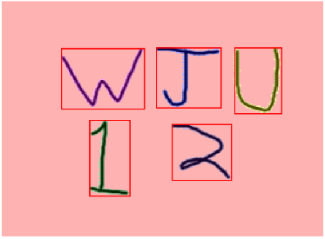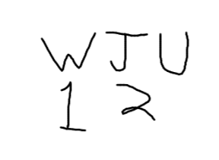Image files are stored in /Image folder. Before model can predict characters in image file, Test program will first divide the image in different regions with one character in each region. Then image is scaled down to 28x28 pixel image and Model uses this 28 x 28 Metrix of image pixels to predict the character. Predicted output is displayed along with processed image.

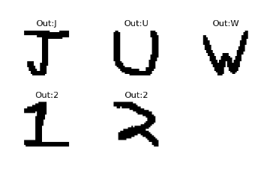

## Evaluate: -

Evaluate function is used to test the accuracy of Machine learning model when using on different Test datasets. When we load new Model or dataset the Accuracy is reset to zero but after we evaluate the model its accuracy will be displayed in the main menu.

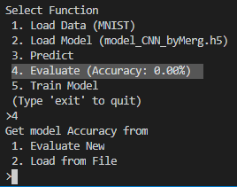We have two option in this function. When we select evaluate new, model is used to predict the output of all the datapoints in test data and new Accuracy values are calculated and stored in “model/modelAcc.json” file.

When we select Load from file, Previously saved values are loaded from “model/modelAcc.json” file if they are available.

After evaluating the Model Accuracy 16 sample images from test data are shown with predicted output(out) and Actual values(label). For the option with newly evaluated accuracy 8 correct and 8 wrong predictions are used but when loading from file 16 random samples are used to display images.

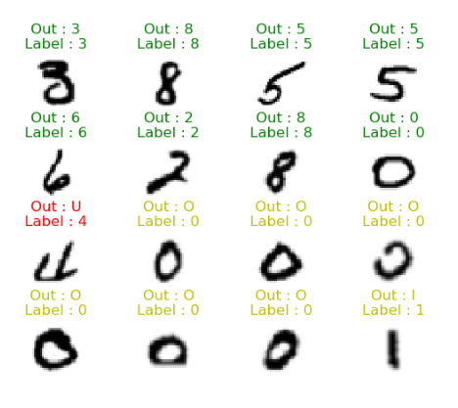Green is for correct prediction and red color for wrong prediction. But when calculating accuracy there are some cases where output does not match the actual label but characters are so similer that it is hard to differentiate them. Cases such as ‘0oO’ , ‘1lL’ , ‘5sS’ etc. are treated as half correct and displayed in yellow.

## Train Model: -

This function is used to train a new machine learning model after selecting a dataset. We can train new models with different parameters but only CNN model training is supported in the test program. We can change number of classifications, batch size, epochs and learning rate for the training. Number of classifications is how many different characters the model can identify it is highly dependent on the selected dataset and should be left as default. A batch is a set of samples used in one iteration of training. When the dataset is too large instead of loading the whole data, we can split it in different sets and train the model in many iterations. One epoch means every sample in the training set has been fed through the training model at least once. Generally larger the number, better the model will learn to predict your data. The learning rate is a hyperparameter that controls how much to change the model in response to the estimated error each time the model weights are updated. Learning rates should be selected carefully as even small changes can have huge effects on how well the model learns.